Here is how to setup the OpenCV library.

1. Download OpenCV 2.4.x (mine is 2.4.6 but it is unavailable now) from sourceforge.net. It’s self-extracting so just double click to start the installation. Install it in a directory, for example, “C:\”.

Wait until all files get extracted. It will create a new directory *C:\opencv* which contains OpenCV header files, libraries, code samples, etc.

1. Add the directory *C:\opencv\build\x86\vc10\bin* to your system PATH. Open **Control Panel** → **System** → **Advanced system settings** → **Advanced** Tab → **Environment variables.**

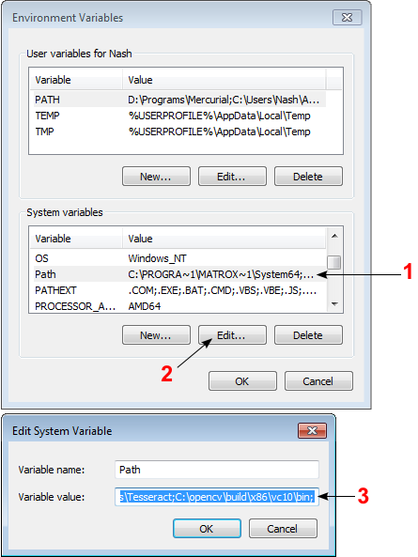

On the System Variables section, select **Path** (1), **Edit** (2), and type *C:\opencv\build\x86\vc10\bin;* (3), then click **Ok**.

1. You will need to configure MSVS 2010. Open a project; make sure the “Debug” is selected in the solution configuration combo box. (If you’re working under “Release”, settings would be almost the same. A slight difference will be mentioned later.) Right click the name of the project and select **Properties** → **VC++ Directories**.

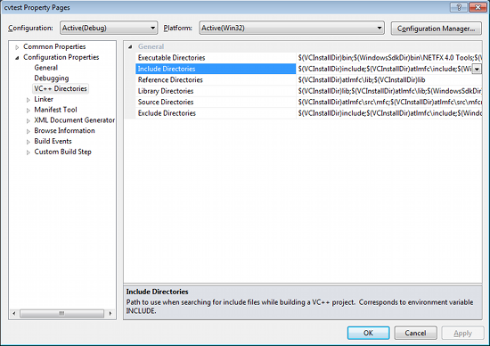

Select **Include Directories** to add a new entry and type *C:\opencv\build\include*. Back the Property and select **Library Directories** to add a new entry and type *C:\opencv\build\x86\vc10\lib*. Click OK to close the dialog.

Back to the property dialog, select **Linker** → **Input** → **Additional Dependencies** to add new entries. On the popup dialog, type the files below:

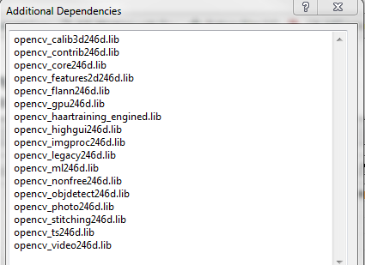

Note that the filenames end with "d" (for "debug"). Also note that if you have installed another version of OpenCV (say 2.4.9) these filenames will end with 249d instead of 243d (opencv_core249d.lib..etc). Click **Ok** to close the dialog. Click **Ok** on the project properties dialog to save all settings.

**NOTE:**

These steps will configure Visual C++ for the "Debug" solution. For "Release" solution (optional), you need to repeat adding the OpenCV directories and in **Additional Dependencies** section, use:

opencv_core246.lib  
opencv_imgproc246.lib  
...

instead of:

opencv_core246d.lib  
opencv_imgproc246d.lib  
...